Yunmin Lee
etHICAL dIMENSIONS | aNCIENT gREECE
Unit 1
Freedom and Discrimination in athens
Growing up in sparta

A
ncient Greece was an interesting country known for its magnificent gods, historical temples, and their great mountains and nature. But as this country has beauty, it also had a dark side – Discrimination. Women, Children, and slaves didn’t have much freedom at all in ancient Greece; or any other ancient country, in that matter.

The Freedom and Disadvantages in Athens
Women
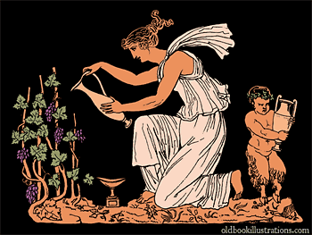
Greek Women were one of the most unlucky beings in the Ancient times. They had almost no freedom. Their lives were practically controlled by the hands of men- Her Father, before marriage, and her husband, after marriage. Girls had to do exactly as their father told them to do. They were not allowed to marry the man they want – It was up to their fathers to choose the man they would marry. Girls married in their mid-teens while their mate (the man) married in their late 20’s or 30’s. They were never allowed to become a full citizen, I repeat, ever, and were not allowed to leave the house without a male companion. The choices they made had to have permission from their father or husband. Their only chance of having a comfortable elderly life was a son. At birth, all children were treated as a blessing, but after a while the female children were treated the same – learning housework, making a living, without education.
A Greek woman waters her grape vines with her young child.
The exception of Spartans
But this only went for Athenian women. The Spartans, however, allowed a woman to participate in sports and fight in wars. Spartan women had to be strong to be alive at all. When a baby was born in Sparta, They were inspected carefully, and the crippled and weak ones were killed or trained as a slave. The strong ones were educated strict, especially fitness was considered very important. Spartan people were mostly strong.

MEN
Men had a much better life than women. They are the ones who got the important decisions, such as daughters’ marriage, or control of their wives acts. They were the ones who gave permission. Normally they were the ones who fought in wars and took parts in sports events. They held drinking parties and entertained their male friends. Women and children were never allowed to attend in any of their parties. In larger homes, the men had their own dining room – while they ate, the woman waited on them outside and would have their own meal out in the courtyard of their privacy. Basically, a man’s word was law to women. So a short conclusion is, Women stayed in, and men adventured out.

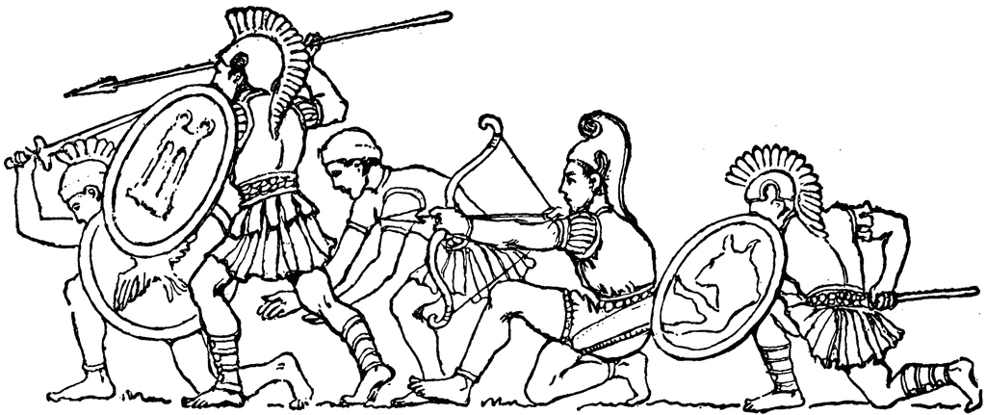
Greek male soldiers ready to battle.
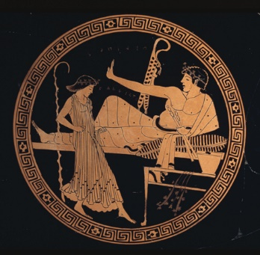
Slaves
Slaves of ancient Greek homes were considered a normal thing to do. Only the poorest of homes had the women do the work instead of slaves. So slaves were practically a normal person to have. They were usually female slaves who knew how to cook, clean, and collect fresh water every day. Some slaves were treated very well and considered a family member, while the unlucky ones are being treated very badly – what we, the modern people commonly known as ‘slavery’. If a slave made a mistake in a strict home, they would be punished pretty harsh such as getting whipped. Most commonly, fifty whips. There were male slaves, too. They did housework like any other slave and sometimes educated young male children.
Predicted to be a slave girl entertaining her male master.

Children
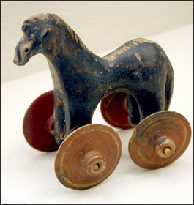
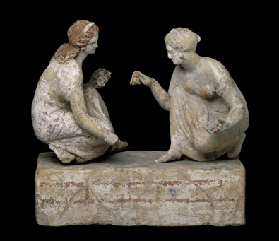
When a baby was born in ancient Greece, it was a cause for celebration. The Greeks loved dance. So of course they had a dance the father did, holding his new baby. The mother made a wreath for the door so everyone would know they had a new baby. Friends and family brought gifts. Sparta was the exception (of course.) When a baby was born, it was looked over very carefully. If the child was not perfect, it was killed. The Spartans had no interest in raising a child who was not physically able to become a great warrior. For those families who did not have slaves to do all their work, even toddlers helped in the fields. Until age 6, nearly all children, boys and girls, were taught at home, by their mother. There was time to play. Kids played a game similar to basketball. They had little carts they pulled around. They loved games of skills, like tossing sticks into buckets. They listened to stories, fables, and legends.
A Children’s wheeled horse toy
Two Athenian Girls play a game of
Knucklebones, a game played like Jacks.

Sparta – The Ruthless
Just because Athens had a lot of discrimination, it doesn’t mean there wasn’t an exception. The Spartans had a free life, but also had to be very dauntless. Their local god is Ares, the god of war, a perfect theme for the people of Sparta.
What were the objectives of education in Ancient Sparta, and how did education prepare students for their roles in society?
Spartans believed in a life of 'discipline, self denial, and simplicity,' and so the purpose of education was, simply, to produce an army. When babies were born, soldiers came to check the child. If it appeared healthy and strong, they would be assigned to a 'brotherhood' or a 'sisterhood,' however if the baby appeared weak and small, the infant would be left to die on a hillside or taken away to be trained as a slave.
Male Spartan children were sent to military school at the age of six or seven. They lived with their brotherhood. School courses were very hard and painful for boys, so school was described as a 'brutal training period.' Between the age of 18 and 20, Spartan males had to pass a fitness test that consisted of fitness, military ability, and leadership skills. If he didn't pass, he became a person who had no political rights and was not even considered a citizen. If he did pass, he would continue to serve in the military and train as a soldier until he was 60, when the soldier could retire to live with his family.
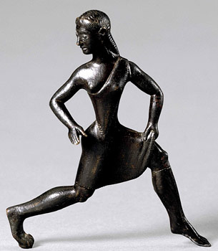
Girls were trained in their sisterhood, and were taught physical education, unlike the Athenian girls. They also started school at the age or six or seven. It is unknown as to whether their school was as rough and hard as the boys', but some historians believe the two schools were very similar in their objectives, to produce a strong group of women. At age 18, the Spartan girl also had to pass a fitness test. If she passed, a husband would be assigned to her, and she would be allowed to go home, however if she failed she would also become a citizen. A woman in Sparta things were very different for citizen women than they were in other Greek cities, where women would stay home most of their lives and be controlled by their husband. In Sparta, women had a lot of free will and were almost as good fighters as the men.
Spartan Girl
Athens-
Had artisans, poets, philosophers
Sparta-
Had warriors, some artisans
Athens-
Democracy
Sparta-
Military Oligarchy
Athens-
Women treated poor
Sparta-
Women treated better, could have jobs
Athens-
Slaves treated better, had jobs
Sparta-
Slaves treated very poorly, beaten
Athens-
Boys educated
Sparta-
Boys and Girls had military education

Athens VS. Sparta
What subjects did students take in Ancient Sparta and why?
In ancient Sparta, reading and writing were not very important, so they were taught as a secondary skill for both boys and girls. Education was very military focused for boys and girls, so most of the skills they learnt in school were combative and war centered. The children learnt survival skills and other skills vital to being a soldier. Because the Spartan government wanted Spartans to be tough and strong, they weren't given enough food or clothing, so they were encouraged to steal, but if they were caught they were beaten. That was the Spartan way: Lie, cheat, steal, and get away with it, or else.

Check your understanding
- How were Athenian Women treated?
- How were Spartan Women treated?
- Imagine you were an Athenian women. How would you feel? What would you think should change?
- Draw a Venn diagram comparing Sparta and Athens. How many similarities can you find?
- Would you rather be an Athenian Man or Spartan Woman? Explain why.
- Choose Either Athens or Sparta. Make a list of things you think should change in the city.

Works Cited
"Ancient Greece." BBC News. BBC, n.d. Web. 25 Feb. 2015.
"Ancient Greek People." MrDonn.org. N.p., n.d. Web. 01 Mar. 2015.
"Ancient Sparta." Education in Ancient Athens and. N.p., n.d. Web. 04 Mar. 2015.
BBC News. BBC, n.d. Web. 04 Mar. 2015.
"Daily Life in Ancient Greece for Kids." Daily Life in Ancient Greece for Kids. N.p., n.d. Web. 01 Mar. 2015.
"EHow | Electronic Know-How." EHow. Demand Media, n.d. Web. 01 Mar. 2015.
"Greek Soldier." ClipArt ETC. N.p., n.d. Web.
"How Greek Slaves Were Punished." Answers. Answers Corporation, n.d. Web. 04 Mar. 2015.
"Welcome to » Old Book Illustrations: Pictures Scanned from Old Books." Old Book Illustrations. N.p., n.d. Web. 04 Mar. 2015.
"Women in Ancient Sparta." Wikipedia. Wikimedia Foundation, n.d. Web. 04 Mar. 2015.

