Ancient Rome and Armies
Introduction
The Roman Army ranged from 14000-16000 soldiers. At its largest state. There are about 20 legions in one army containing about 4000-6000 people. They had 10 cohorts in one legion. The Roman Army was well known around Europe. They conquered many places around the world. The Roman Army was ruled by many Generals and Leaders. 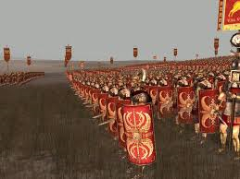

Did You Know?
That roman soldier carried at least 3 weapons into battle.
By: Colby and Zach
Weapons and Armour By: Colby and Zach
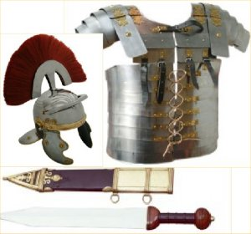
The Romans invented good weapons and armour. That’s what made them so powerful. Here are some examples. The Gladius is a sword that Roman soldiers used. The Gladius is basically a regular sword. It was adopted by Romans from Celtic tribes of Spain. The Pilum was a javelin that was thrown when the army charged. It could penetrate enemies shield. The end fell off when it hit something hard so the enemies couldn’t pick it up. The Hasta is a spear. It is about 2 meters long and the shaft is made of ash. It was the first and last great Roman weapon. The Plumbata was a throwing dart or arrow. It was adopted from the Greeks. The Pugio was dagger or knife.
Did You Know?
That in Roman time’s bows were considered cheap weapons. Were said to require no skill or honour.

Every soldier in the army carried one and they were well favoured. The Spathea is a long sword. It was originally used by the cavalry unit but became used by the infantry. The hilt was usually made of wood. The armour was made up of 3 pieces. The cassis {helmet} and the body armour. They were made of iron strips fastened together with laces, hook and hinged at the back.
Army Tactics
The Roman had many army tactics. They had formations that protect themselves from enemy fire. A few of these formations are. The Tortoise {as shown below} is a formation where soldiers make a shield wall in front and above them. The Pigs Head was where soldiers formed a wedge shape pushed away the enemy with their shields. The Square Formation is square formed with interlocking shields. The army approached in a certain formation {as shown below}. The infantry and the Auxiliaries attacked first then the reserves and the cavalry came in and the commanders stayed back and commanded the lesser army men. Here army commands, signa inferre=to attack. Signa Referre=to attack. Signa converte=turn around. Conversa signa inferre=to turn around and attack. Here are the roman army ranks. Recorded highest to lowest Commander/General, Legates/Lieutenants, and Military tributes, Centurions, Optio/Signifier/Tesserarius, Immunes, Roman Standards, Avocati/Veteran Soldiers and Munifex/Roman Soldiers. 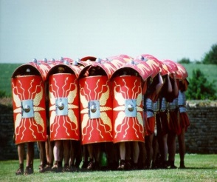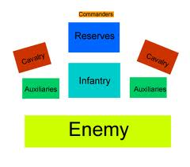
Did You Know?
That Roman’s usually stuck discarded spear heads, sharpened sticks and loose rocks in their ditches to protect themselves.
Army Camps
Did You Know?
That the daily army meal might consist 22 items. Including drinks.
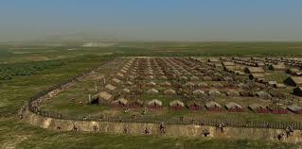
The Romans had very organized army camps. The Romans dug ditches to protect their camps. There were about hundred tents in one army camp. There were ten tents to one cohort. Each tent had eight people assigned to it.

By: Colby and Zach
Conclusion
The Roman Army was a big group of battle ready soldiers. With about 14000-16000 soldiers. The romans used many battle formations. Many were shield walls in different shapes. The roman weapons were very well made weapons. their Armour was made of iron strips attached to each other. The romans dug ditches to protect their camps. The camps contained about one hundred tents with eight people.
Glossary
Legion= A group of about 4000-6000 soldiers in an army.
Cohort= A group soldiers in a legion.
Gladius= A roman Soldier sword.
Pilum= A Roman javelin.
Hasta= A two meter long Roman spear.
Plumbata= A weighted throwing adopted from the Greeks.
Pugio= A dagger or knife.
Spathea= A long sword originally used by cavalry.
Cavalry =messengers and scouts.
Infantry=Regular Soldiers.
Tortoise = An army formation shaped like a tortoise shell.
Pigs Head= An army formation shaped a wedge.
Square Formation= An army formation shaped like square.
Auxiliaries=Border Patrols.
Commanders= People who commanded the army.

By: Colby and Zach
Questions
Did other countries fear the Romans?
Where did the Romans get the material for their weapons?
Why did the Romans carry so many weapons?
Why did the Romans drink beer when it could cause drunkness?

?
Reflect
What did you learn?
Look back in time and imagine being in the Roman Army?
Would you be in the Roman Army?

By: Colby and Zach

Agosta, Loredana, Anne McRae, Lorenzo Cecchi, Luisa Della Porta, Alessandro Menchi, Manuela Cappon, Monica Favilli, and Paola Ravaglia. Ancient Rome. Florence, Italy: McRae, 2008. Print.
"Ancient Roman Military, Army - Crystalinks." Ancient Roman Military, Army - Crystalinks. N.p., n.d. Web. 01 Mar. 2015. <http://www.crystalinks.com/romemilitary.html>.
"Ancient Rome." History of for Kids: The Roman Army and Legion. N.p., n.d. Web. 26 Feb. 2015.
Dark Night. N.p., n.d. Web. 3 Mar. 2015. <http%3A%2F%2Fwww.darkknightarmoury.com%2Fs-25-roman-daggers.aspx>.
Darling, David. "Roman Camp." Roman Camp. N.p., n.d. Web. 24 Feb. 2015. <http://www.daviddarling.info/encyclopedia_of_history/R/Roman_camp.html>.
"Famous Romans." Famous Romans. N.p., n.d. Web. 01 Mar. 2015. <http://www.roman-empire.net/children/famous.html>.
"The First Romans in Carnuntum." Lbi-admin. N.p., n.d. Web. 04 Mar. 2015.
"Fortified Camps | Tools of War | The Roman Military." Fortified Camps | Tools of War | The Roman Military. N.p., n.d. Web. 24 Feb. 2015. <http://romanmilitary.net/tools/camp/>.
Gill, N.S. "Roman Army - Recruitment, Legions, Siege Warfare & More." N.p., n.d. Web. 25 Feb. 2015. <http://ancienthistory.about.com/od/romeweapons/p/RomanArmy.htm>.
"GLADIUS MACHETE." Gladius Machete. N.p., n.d. Web. 02 Mar. 2015. <http://www.coldsteel.com/Product/97GMS/GLADIUS_MACHETE.aspx>.
"History." Roman Legionary Soldier of the Second Augustan Legion. N.p., n.d. Web. 02 Mar. 2015. <http://www.caerleon.net/history/army/pilum.htm>.
Lloyd, James. "Roman Army." Ancient History Encyclopedia. Ancient History Encyclopedia, 30 Apr. 2013. Web. 25 Feb. 2015.
N.p., n.d. Web.
"Pics For Roman Weapons Names." Pics For Roman Weapons Names. N.p., n.d. Web. 02 Mar. 2015.
"Pix For Roman Army Formations Tactics." Pix For Roman Army Formations Tactics. N.p., n.d. Web. 03 Mar. 2015. <http://pixgood.com/roman-army-formations-tactics.html>.
"Plumbata (roman Throwing Arrow)." Plumbata (Roman Throwing Arrow). N.p., n.d. Web. 03 Mar. 2015. <http://www.getdressedforbattle.co.uk/acatalog/Plumbata--roman-throwing-arrow--W_1816422000.html>.
"Roman Army." BBC News. BBC, n.d. Web. 24 Feb. 2015.
"Roman Army Camp." Roman Army Camp. N.p., n.d. Web. 26 Feb. 2015.
"Roman Army Formations." Roman Army Formations. N.p., n.d. Web. 03 Mar. 2015. <http://historylink101.com/2/Rome/roman-army-formations.htm>.
"Roman Army Formations." Taleworlds. N.p., n.d. Web. 3 Mar. 2015. <http%3A%2F%2Fforums.taleworlds.com%2Findex.php%3Ftopic%3D2975.1380>.
"Roman Army Index." Roman Army Index. N.p., n.d. Web. 25 Feb. 2015.
"Roman Army." N.p., n.d. Web.
"Roman Rank." Hierarchystructure.com. N.p., n.d. Web. 24 Feb. 2015. <http%3A%2F%2Fwww.hierarchystructure.com%2Fwp-content%2Fuploads%2F2012%2F07%2FRoman-Military-Hierarchy1.jpgfor%20it.>.
"Roman Uniform and Armour." Roman Uniform and Armour. N.p., n.d. Web. 03 Mar. 2015. <http://www.primaryhomeworkhelp.co.uk/romans/armour.html>.
"Roman Weapons." Roman Weapons. N.p., n.d. Web. 24 Feb. 2015. <http://ancientmilitary.com/roman-weapons.htm>.
"Romanarmyfood." N.p., n.d. Web.
"SOUVENIER, STAGE, COSTUME ARMOR." SOUVENIER, STAGE, COSTUME ARMOR. N.p., n.d. Web. 02 Mar. 2015. <http://legvi.tripod.com/armamentarium/id314.html>.
"Spartacus Educational." Spartacus Educational. N.p., n.d. Web. 23 Feb. 2015. <http://spartacus-educational.com/ROMmilitary.htm>.
"Tactics." Tactics. N.p., n.d. Web. 25 Feb. 2015.

